Regression!

Kyle Payne

December 9, 2015

# 1.

## a. Fit the simple linear regression of colonies on dose, and produce the usual R diagnostic plots.

## b. Using the plots, comment on (i) any evidence of lack of fit and (ii) any evidence of heteroscedasticity.

## c. Now fit the simple linear regression of colonies on log(dose+1), and produce the usual R diagnostic plots.

## d. Produce a summary of the regression results.

## e. Produce an ANOVA table of the regression results.

The following R code may be helpful:

library(faraway)

## Warning: package 'faraway' was built under R version 3.1.2

data(salmonella)  
  
mod <- lm(colonies~dose,data=salmonella)  
par(mfrow=c(2,2))  
plot(mod)

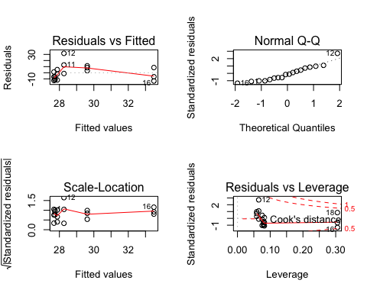

par(mfrow=c(1,1))

## f. For this model, compute a t-test by hand for the slope using the standard error formula.



## g. Calculate and interpret a 95% confidence interval for the intercept. The equation for the standard error is given below.



## h. Calculate the coefficient of determination for the model by hand.

$$R^{2}=\frac{SSR}{SST}$$

## i. Calculate the correlation coefficient for the model.

$$r=\sqrt{R^{2}}$$

## j. Carry out a hypothesis test to determine whether the linear correlation for these data is different from 0.

$$t_{calc}=\frac{r*\sqrt{n−2}}{\sqrt{1−r^{2}}}$$